**Flower Love Game Design Document**

Flower Love is a game where you shoot sad blobs with flowers to make them happy. This document explains what the game is about and how it works

**FlowerBot (Player)**

You play as a robot created for the purpose of spreading happiness to a world of sadness. The player can move using WASD and can shoot using a Flower Cannon. The player emits particles both from movement and shooting. The player also recoils from every shot, being pushed back slightly every time the player shoots.

The sprite has two animations, both a scale animation using an Animation Player, and an Animated Sprite 2D using two sprites.

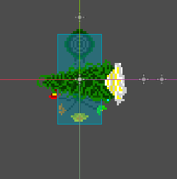

**Flower Cannon (Cannon)**

The Flower Cannon follows the mouse and shoots upon left-clicking. The Cannon plays a scale animation using an Animation Player per shot. It also plays a shooting sound per shot.

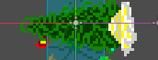

**Flower (Bullet)**

Flowers are what the Flower Cannon shoots at enemies. White particles are emitted upon collision and the flower disappears. The flower plays a collision sound when it collides with something. The cannon uses a timer to prevent spamming.

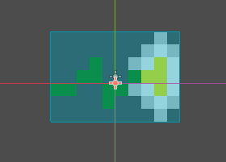

**Sad Blob (Enemy)**

Sad blob are blobs that are sad, and need to be shown love to become happy. This is done by shooting flowers at them. When a flower collides with them, both white and green particles are emitted and a number is displayed showing how much damage they took. When the blob is hit with enough flowers, a smiley face appears on their face and the blob disappears. The camera shakes to indicate a blob has disappeared.

Blobs spawn in a set of 1-3. When all blobs have been made happy, more sad blobs appear.

Blobs play animations using an Animated Sprite 2D, Animation Player and an Animation Tree. Animated Sprite 2D is just like the sprite animation for the player. The animation tree plays the animation from the animation player and the smiley face when the blob is made happy.

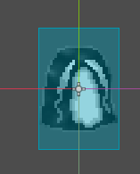

**Game Map**

The game takes place on two tilemap layers and four CollisionBox2D’s forming box so the player can’t leave. The first layer is the floor and the second one is the walls. A camera is in the middle to show the entire layout.

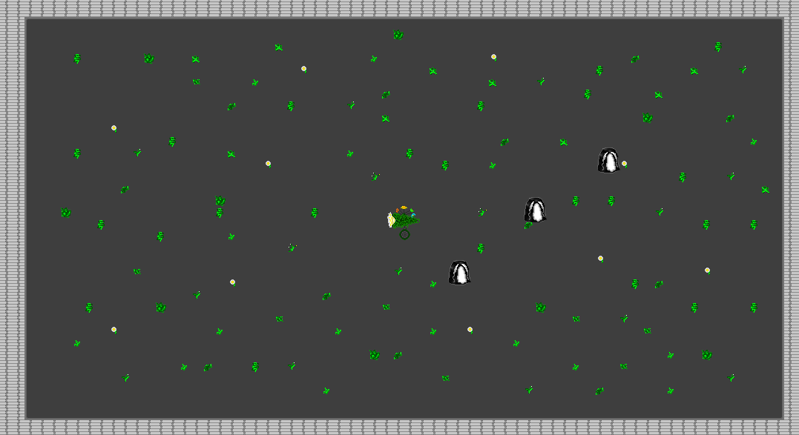

**Art & Sprites**

All sprites were created by me in Photoshop. The tile set was created the same way. The animation frames were created by exporting each frame and adding them to an Animated Sprite 2D. The Tile set still has the old name of the name, which was ‘Flower Bot’.

